
I N T E R N A T I O N A L

F O R U M

O S L O

N E W S L E T T E R
November 2025
Issue No. 512

Coming Events:
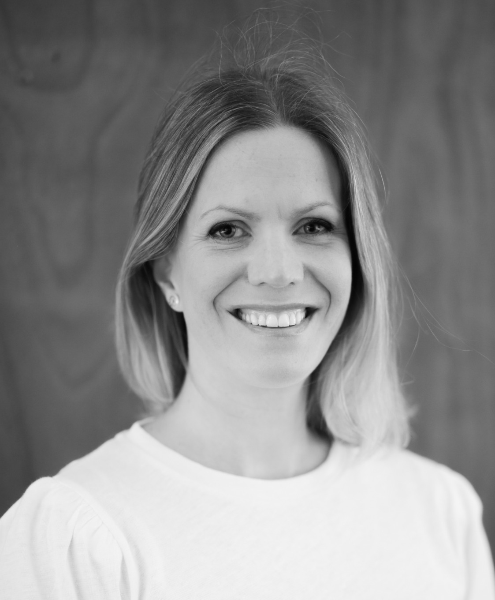
November Monthly Meeting, November 3, p. 7
Karen Greve, Speech Therapist
‘The Power of the Voice’



Extraordinary General Meeting, November 19, p. 5

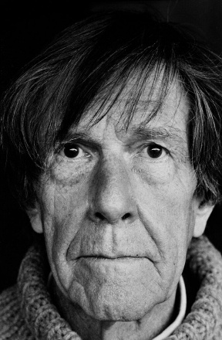

Art Committee, November 20, p. 8
Tom Sandberg at Henie Onstad Art Centre
Black and White Photography

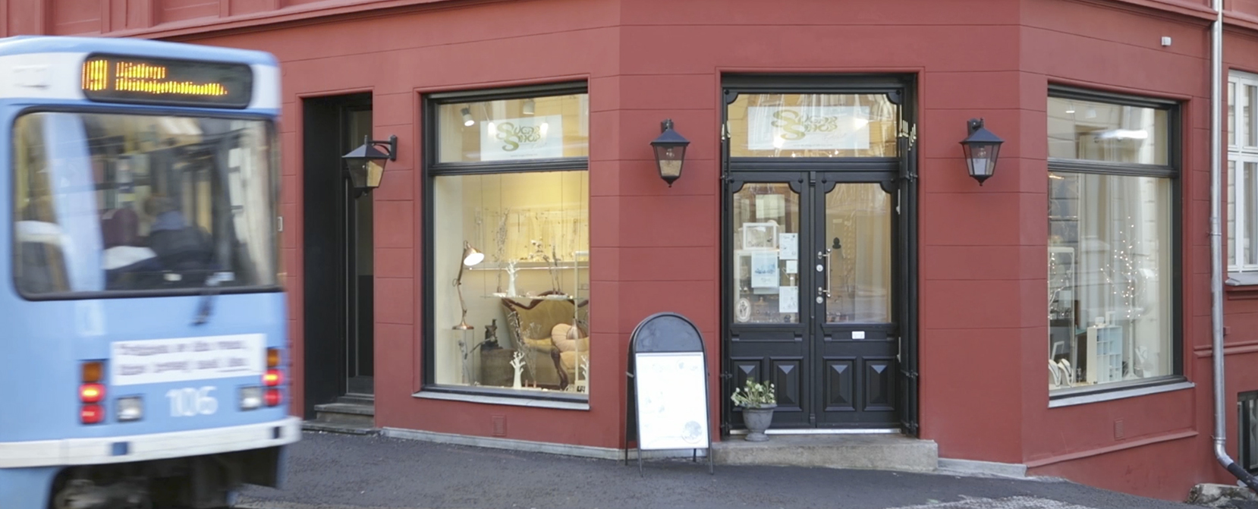
The Sugar Shop, November 25, p. 9
Jewellery Workshop and Gallery



Christmas Meeting, December 1, p. 10

INTERNATIONAL FORUM
P.O. Box 1505 Vika, 0117 Oslo, Norway
Website: www.iforum.no Email: info@iforum.no

Visiting address: Kronprinsens gate 3, Victoria Passasjen, 0251 Oslo
Bank account number: 1600 40 36631
VIPPS to: 591747
Interim Board 2025: Åsny Wedege Walters, Elisabeth Ising Torgersen, Sylvia Krämer, Elizabeth S. Rasmussen
Office: Please send inquiries by email.
Email: info@iforum.no
Editor: Elizabeth S. Rasmussen
Editorial Team: Elspeth Walseth, Robin Wittusen and Renate Scapin
Forum Secretary:
Treasurer: Styreweb Regnskap
Auditor: Verena Krienke
Committee Leaders:
Monthly Meetings: Gunnel Anita Solheim
Special Events: Mona B. Reinboth
Art Committee: Jane Steenbuch
Activities: Gunnel Anita Solheim
Nomination Committee:

If you wish to become a member of International Forum, please contact us by email, and we will send you an application form.

IN THIS NEWSLETTER
FEATURES/EVENTS DATE TIME PAGE
FROM THE INTERIM BOARD
The Interim Board’s Page 4
Notice of Extraordinary
General Meeting Nov. 19 17:45 5
COMING EVENTS
November Monthly Meeting
Karen Greve, Speech Therapist
‘The Power of the Voice’ Nov. 3 17:45 7
Art Committee
Henie Onstad Art Centre
Tom Sandberg: The World Vibrates
Black and White Photography Nov. 20 11:45 8

Special Events
The Sugar Shop
Jewellery Workshop and Gallery Nov. 25 11:45 9

December Christmas Meeting Dec. 1 17:45 10

ACTIVITIES
Wednesday Bridge Group Nov. 12 10:30 11
REPORTS
October Monthly Meeting
Linken Apall-Olsen on Urban Planning in Oslo 12
Special Events
Guided Walk Down Akersgaten 15
Art Committee
Ludvig Karsten: Restless 19

IN MEMORIAM
Kirsten Wensell 24
AROUND OSLO
Fjord Oslo Festival of Lights 25

DEADLINE FOR SUBMITTING ARTICLES
For the December Newsletter, the deadline is November 15. Please send your contribution to Elizabeth S. Rasmussen by email and to info@iforum.no. The Editorial Team reserve the right to edit all material.

THE INTERIM BOARD’S PAGE
Dear Members,
This autumn, the Forum has had the pleasure of welcoming six new members. We hope that they will participate in our events and activities and that they will feel welcome in the various groups and activities that Forum organises.
October has come and gone, and we are now on regular winter time. Some of us are preparing the garden for winter, cutting branches and cleaning up. We’ve had beautiful autumn colours, a sure sign of change. The days are now quickly getting shorter, and the sunrises will be as colourful as the sunsets.
The Office in Victoriapassasjen will be packed up by the end of November. A lot of memories to sift through! The Foreign Office moves to a new building, and the Forum will lose its meeting room and printing privileges, so this November Newsletter is the last to appear in print. That makes me feel a bit sad. It has been such an exciting journey for me! And I have learnt so much from the glorious ‘girls’ on my Editorial Team – Robin, Elspeth and Renate – we have become such a close group.
The Board encourages our members to read the revised Statutes that we have sent out along with the invitation for the Extraordinary General meeting held on November 19, when we will elect a new Board.
We hope that you will enjoy the remaining Forum events this autumn.
The annual Christmas meeting is on December 1. The Christmas meeting offers a fun and convivial evening! Wine and sing-along are a good mix! We hope to see you there in great numbers!

Elizabeth S. Rasmussen
Board Member


NOTICE OF THE EXTRAORDINARY GENERAL MEETING
Majorstuen Seniorarena
The EGM is only for members.

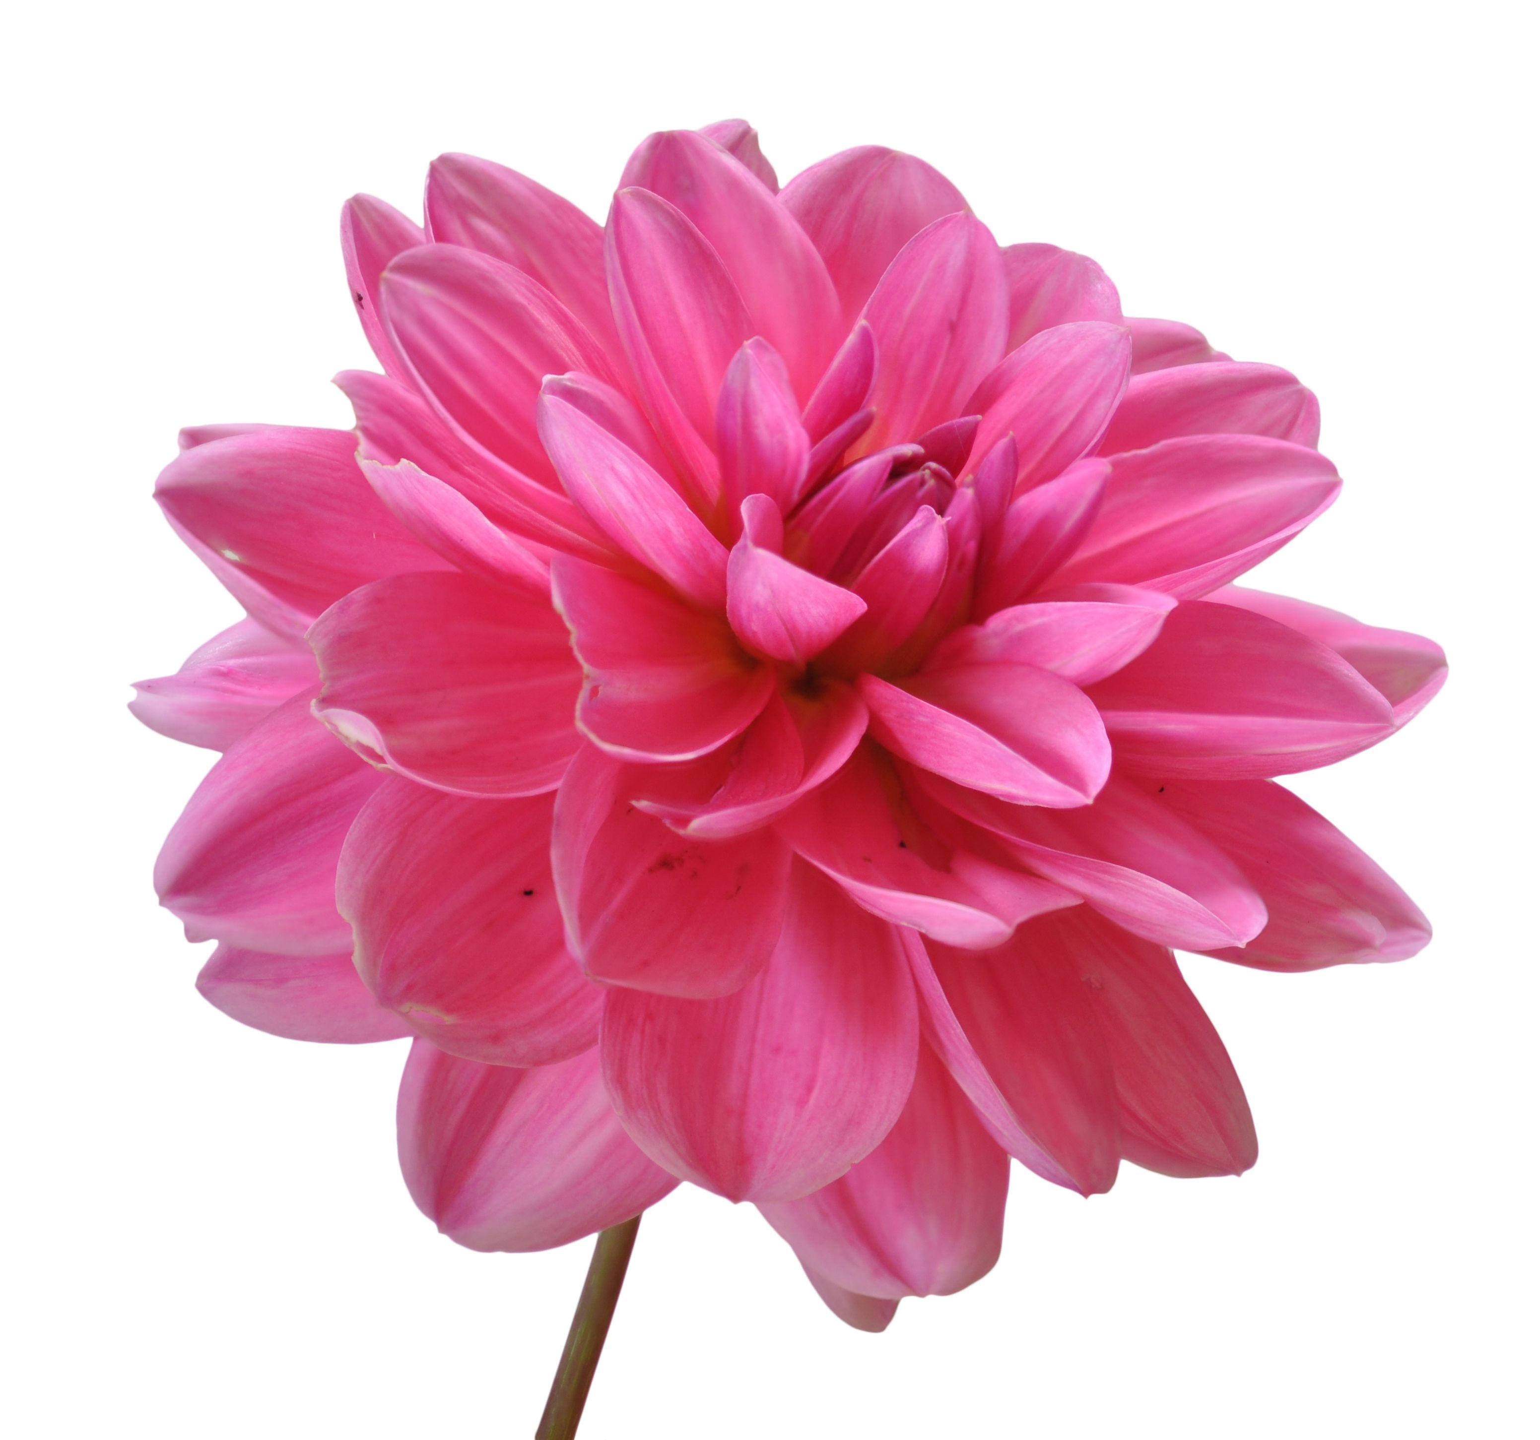NEW FORUM MEMBERS
This month the Interim Board is very happy to welcome two new Forum members.

C O M I N G E V E N T S
NOVEMBER MONTHLY MEETING
Speech Therapist Karen Greve
‘The Power of the Voice’
Monday, November 3
Ms. Karen Greve will focus on the very important part that our voice plays in life, health and communication, what it tells us about other people, and what it can reveal about ourselves. She will include some practical tasks that the audience can take part in and hopefully take home with them and use.
DATE /TIME: Monday, November 3 at 17:45 (for 18:00)
SIGN UP: Elizabeth Rasmussen by email: as soon as possible.
For more information, please see the October Newsletter.

ART COMMITTEE
Henie Onstad Art Centre
Tom Sandberg: The World Vibrates
Thursday, November 20
The Art Committee invites you to a guided tour of the first major retrospective exhibition of his career.
Tom Sandberg – one of Norway’s most significant and prolific art photographers, whose work has gained international recognition – is celebrated for his atmospheric black-and-white photography and exquisite modulation of grey tones, ranging from pitch black to pure white.
Tom Sandberg, Portrait of John Cage, 1983.
Henie Onstad Collection
The exhibition features many of his iconic works as well as lesser-known pieces that highlight his experimental approach to format and technique. Sandberg’s subjects range from precise framings of everyday moments to urban landscapes, nudes, portraits, horizons, clouds and smoke formations, representing four decades of his work.


DATE/TIME: Thursday, November 20 at 11:45 (for 12:00)
SIGN UP: Bente Skarsgård by mail as soon as possible and no later than November 15.
PLACE: Henie Onstad Art Centre, Sonja Henies vei 31, 1311 Høvik
PRICE: Free entry, but NOK 115,- for the guided tour, to be paid preferably by VIPPS to 591747 or by bank transfer to IF’s bank account 1600.40.36631, when your participation has been confirmed. Please state the event and your name in the transaction (in the dialogue box for VIPPS and in the KID-number box for bank payment).
No cash will be handled at the venue.
TRANSPORT: Høvikodden is around 15 minutes by car from downtown
Oslo. The exit from the E18 to the Henie Onstad Art Centre is well sign-posted. Ample pay parking is available at the centre. Bus 160 leaves every 15 minutes between Oslo and Sandvika. The bus stop is Høvikodden, and it takes about seven minutes to walk to the Art Centre.
There is a café on site.
Maximum number of participants: 25
Guests are welcome if space is available.
Cancellations after the deadline and no-shows will be charged.
For last-minute cancellations or questions, please call Bente on mobile phone.

SPECIAL EVENTS COMMITTEE
The Sugar Shop
Fabulous Norwegian Design Jewellery!
Tuesday, November 25
The Special Events Committee has the pleasure of inviting you to the Sugar Shop Gallery at Briskeby. This gallery workshop is all about the handcraft and skills needed in jewellery making.
Sugar Shop is owned by Elisabeth L. Due. Her goal is to encourage young people to become goldsmiths and to ensure that Norway will have goldsmiths in the future. She is a strongly dedicated firesoul who promotes Norwegian jewellery design and supports small workshops all over the country with great enthusiasm.
Elisabeth L. Due has a three-year BA with honours in jewellery design from Central Saint Martins at the University of the Arts London. She has also studied jewellery design and goldsmithing skills at Sir John Cass London Guildhall.
Every piece is carefully crafted by hand and inspired by the beauty of nature, something that is reflected in the forms, colours and textures.
New to Sugar Shop is art and crafts such as paintings, glass objects and ceramics – all Norwegian design – in her beautiful small gallery workshop at Briskeby.
There will be special offers exclusively for International Forum and special deals regarding new projects concerning old gold or old silver.
DATE /TIME: Tuesday, November 25 at 11:45 (for 12:00)
SIGN UP: To Mona B. Reinboth, by email no later than November 18. Please sign up and pay after you have received confirmation.
PLACE: Sugar Shop, Briskebyveien 30, 0259 Oslo
PRICE: NOK 35,- for a gift.
Please make your payment preferably by VIPPS to 591747 or pay by bank transfer to the IF account:1600.40.36631. Please state the event and your name in the transaction (in the dialogue box for VIPPS and the KID-number box for bank payments). No cash will be handled at the venue.
Maximum number of participants: 20
Guests will be allowed if space available.
Cancellations after the deadline and no-shows will be charged.
TRANSPORT: Public transport by bus 21 from Tjuvholmen or Solli plass to
Riddervoldsplass. There is currently no tram between Nahionaltheatret and Majorstuen via Briskeby. See Ruter 21 buss - Oslo og Akershus.
Click on link to see on a map: sugar shop oslo - Bing Maps
LUNCH: Please indicate if you would like to go for refreshments at
Albin Up gallery nearby the Sugar Shop
For questions or last-minute cancellations, please contact Mona Bækkelund Reinboth by mobile phone or by email.

DECEMBER CHRISTMAS MEETING
Monday, December 1 at 17:45
The Monthly Meeting Committee has the pleasure of inviting you to the traditional Christmas meeting. As is custom, we are planning a raffle, so we ask each member to please bring a small, wrapped gift. The raffle sticks are NOK 50 each (10 numbers on each stick). You can pay by VIPPS. The proceeds of the raffle this year will be donated to the Atlas Alliance, an organisation promoting the rights and improved living conditions of persons with disabilities in the Global South.
There will be a sing-along and refreshments: buffet, wine, mineral water, coffee, tea and cakes.
We ask our members to kindly be seated by 18:00.
We look forward to a convivial and festive evening with friends!
DATE/TIME: Monday, December 1 at 17:45 (for 18:00)
SIGN UP: To Gunnel Anita Solheim by email as soon as possible and no later than Wednesday, November 26. Because of the catering, we need to know as early as possible how many are coming.
Please state if you prefer gluten free bread.
Maximum participants: 60
PLACE: Majorstuen Seniorarena, Slemdalsveien 3a, 0369 OSLO
PRICE: NOK 350.- Please make your payment preferably by VIPPS to 591747 or by bank transfer to the Forum account: 1600 40 36631. No cash will be handled at the venue. Please state the event and your name in the transaction (in the KID-number box for bank payments and in the dialogue box for VIPPS).
Raffle tickets are NOK 50.-. If you wish, you may pay before the meeting by VIPPS 591747 or by bank transfer to the Forum account: 1600 40 36631. Please state your name and ‘Raffle’ (in the KID-number box for bank payments and in the dialogue box for VIPPS).
TRANSPORT: All T-bane lines to Majorstuen. Trams 12 and 15. Buses 20, 25, 45 and 46.
No-shows will be charged.
For last-minute cancellations, please call Gunnel Anita Solheim on mobile phone.

A C T I V I T I E S
WEDNESDAY BRIDGE
The next Wednesday bridge will be on November 12 at 10:30.
Bodil Evensen is hosting this bridge morning. Please call Bodil on mobile phone or send her an email if you want you join us.
We play individual bridge and enjoy a light lunch after the play. Please join our nice group for an enjoyable game of bridge!
The Christmas bridge will be on December 12 at 10:30 and is hosted by Unni Skogen Please call Unni on mobile phone or send her an email if you want to join us.
Please join, we have plenty of space!
If you have any questions, you can also call Inger Støtvig.
R E P O R T S
OCTOBER MONTHLY MEETING
‘Modernism in Oslo, a New Lifestyle in a Green City’
Linken Apall-Olsen
Monday, October 6
Oslo’s modern character did not emerge by chance. In a fascinating lecture on urban planning and architecture, we were guided through the story of how Modernism shaped the city – not just its buildings, but also its values. Ms. Apall-Olsen traced the development from late 19th century industrial urban squalor to 20th century visions of a functional, green, and egalitarian city.
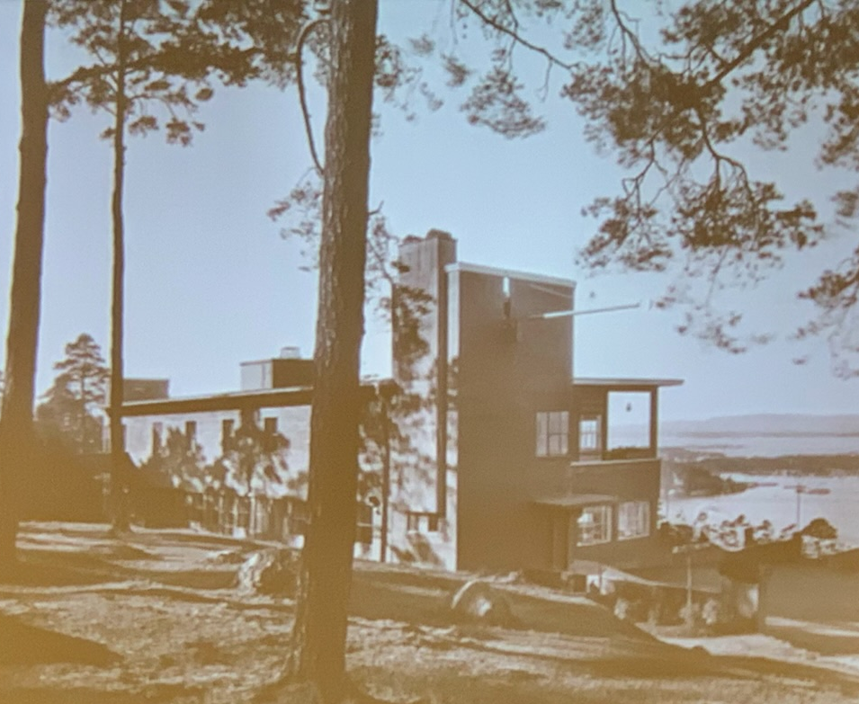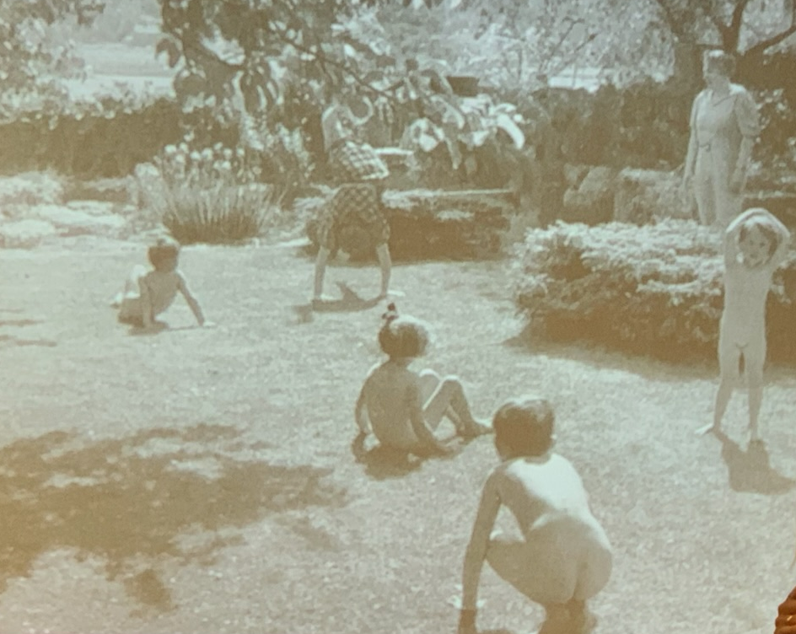
In the late 1800s, industrialisation caused overcrowding and poor living conditions, especially in the eastern parts of the city. Families lived in dark, damp tenements, in winter often without sunlight for months. This led to high rates of disease and death. Women working in public health and education began raising the alarm. Their concerns sparked cooperation across professions — health workers, architects, engineers, and politicians – all seeking better ways to design the city.
Apall-Olsen used photos and paintings – especially works by painter Christian Krohg – to instil empathy and understanding. Photos of children queuing for food, of unemployed workers, and of overcrowded tenement blocks gave a vivid picture of the hardship. At the time, these images served as evidence in public health campaigns by reformers like Nanna Broch, who photographed and documented living conditions in order to stir public awareness and political action.
A new vision for the city emerged. Architect Harald Hals, Oslo’s chief town planner from 1914 to the 1940s, played a lead role. He believed that cities should offer light, air, green space, and dignity to all citizens – not just the wealthy. Under his leadership, Oslo got wider streets and better light conditions in homes: green parks and courtyards in new housing areas; zoning rules to separate traffic, housing, and playgrounds; and public housing with a focus on health and affordability.
Norwegian architects were inspired by urban planning and development campaigns in England and Europe. The lecture highlighted the influence of Le Corbusier and the ‘garden city’ ideas from England – combining homes, gardens and community spaces in one plan.
Green spaces were considered an essential right, not just a decorative feature. Trees (often birch, pine, and spruce) were planted, and city parks became gathering places for play, rest and health. Areas like Torshov and Sinsen were planned with these ideals in mind.
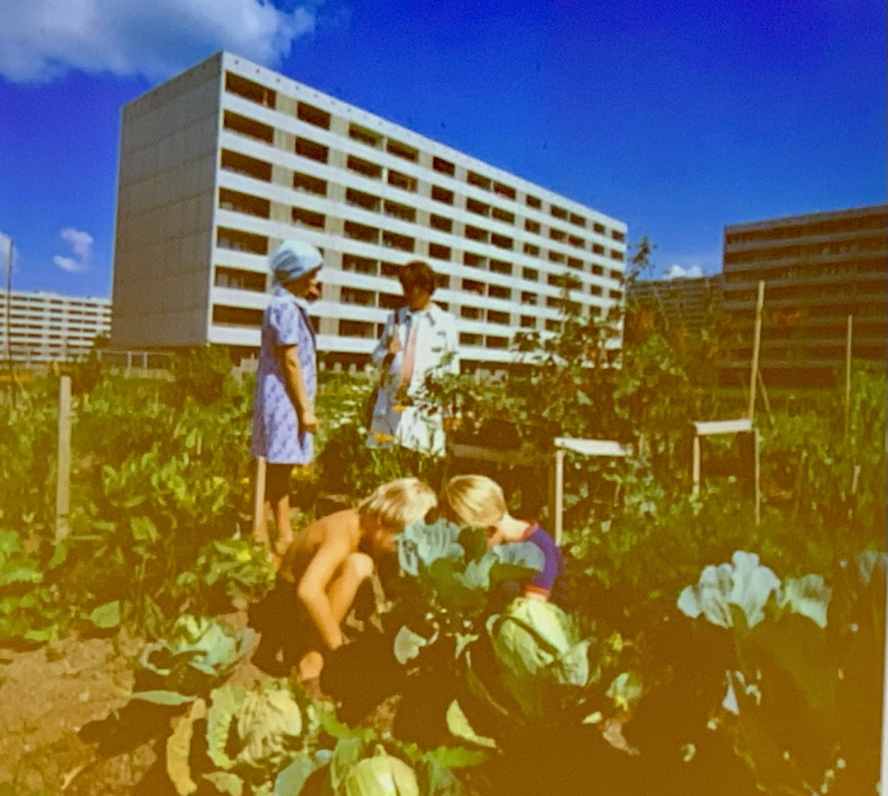
Even footpaths and safe school routes were designed to protect children from traffic – long before this was common elsewhere.
Ms. Apall-Olsen accompanied her talk with illustrations of the new concepts and iconic buildings: images of early 20th century slums and health inspections in schools; Modernist housing blocks in Torshov and Sinsen; examples of garden city planning and pedestrian zones; posters from Sweden and Norway promoting the benefits of green spaces; diagrams showing zoning concepts (residential, recreational, traffic-separated); the Ekeberg restaurant (above) and other early Modernist architecture.
The speaker ended with a reflection upon Modernism in our times. While some Modernist ideas still influence Oslo’s layout, many newer developments seem to forget the core values of Modernism. As one member commented, some newer neighbourhoods are too dense and lack proper green space for children.
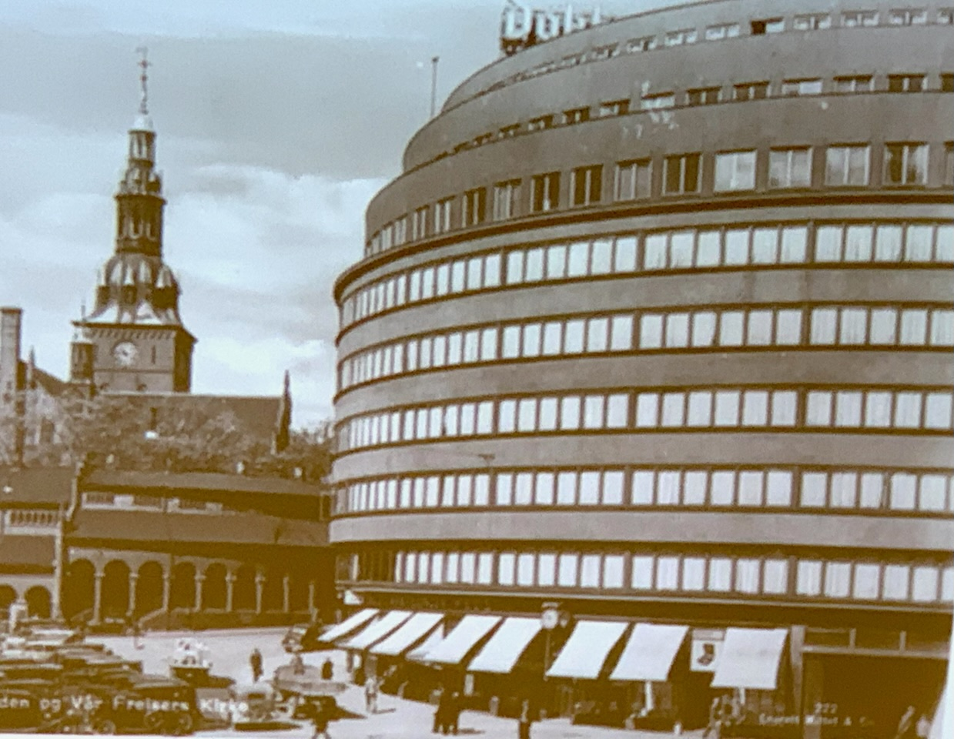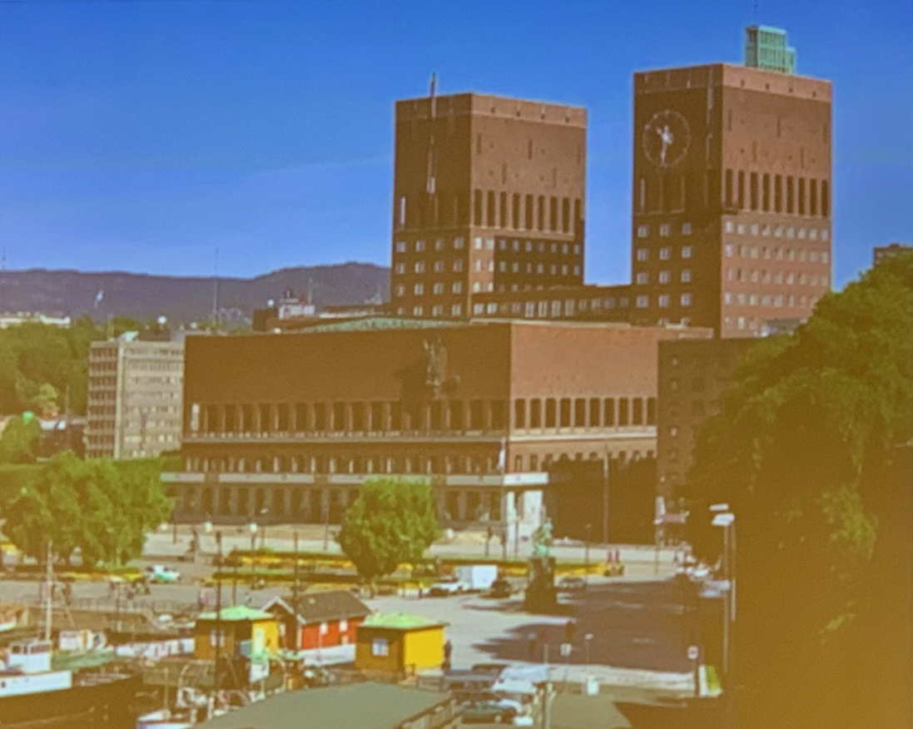
Modernism wasn’t just about style; it was about creating a city that cared for its inhabitants. The lecture reminded us that we should hold onto those values as Oslo continues to grow.
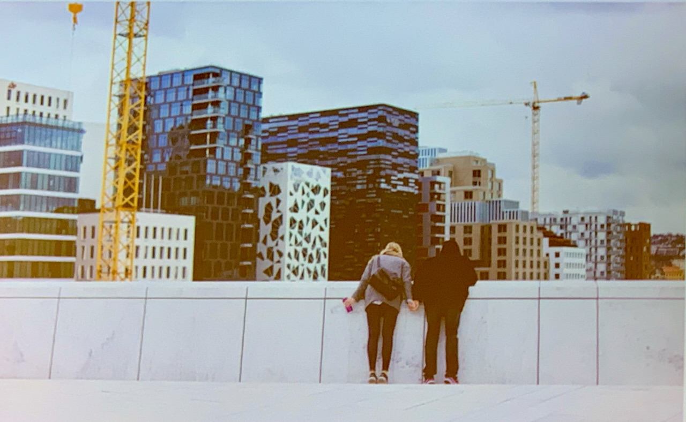
We thank Linken Apall-Olsen for a very interesting and inspiring lecture.
Gunnel Anita Solheim
SPECIAL EVENTS
AKERSGATEN WALK
Tuesday, September 23
In glorious autumn sunshine, 20 ladies and one gentleman gathered at the intersection of Akersveien and Telthusbakken, just below Old Aker Church (Gamle Aker Kirke). Those of us who walked up Telthusbakken admired the picturesque old wooden houses and the lush allotments on our way.
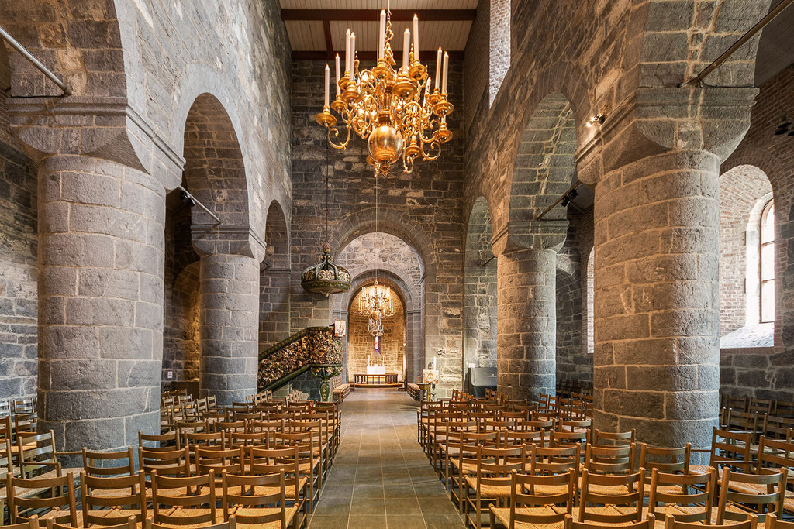
Old Aker Church
Our guide Liv Berit Tessem was there to meet us. Liv Berit has been a journalist with Aftenposten for over 30 years, partly in England, and is now an Oslo guide. She was ready to guide us down her favourite street, named both Akersgaten and Akersveien depending on the area where the street runs.
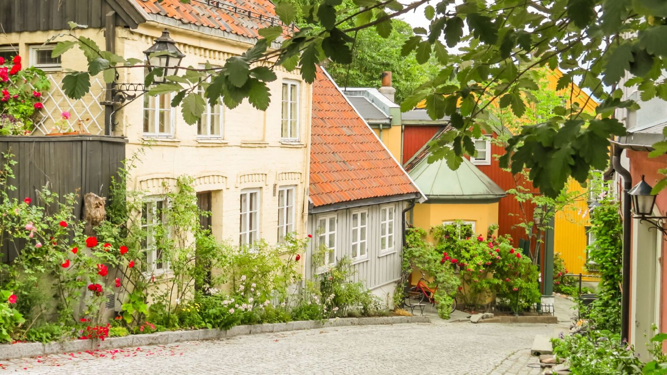

Telthusbakken

Liv Berit began by talking about the area where we were gathered. The name Aker (‘field’) tells us that the soil was very fertile. There were many large farms in this area in medieval days.
We admired the beautiful Old Aker Church, whose construction started in 1080, 50 years after the christening of Norway. It had been a wooden church, but the church we see today, built in the Romanesque style around 1150 in limestone, is Oslo’s oldest building. It has been restored several times, the last time in 2023. Under the church was a silver mine. After the mine was closed, the underground rooms were used for storage. Telthusbakken was named after a canvas storage house, which was built for military purposes at the top of the hill in 1755. The street is now famous for the picturesque old wooden houses and the allotment gardens.
We then walked down towards the town. On our left, on the top of the hill called Udsikten (‘the view’), we could admire Egeberg Castle, an enormous manor house built in 1901 at St. Hanshaugen by Einar Westye Egeberg, now converted into flats.
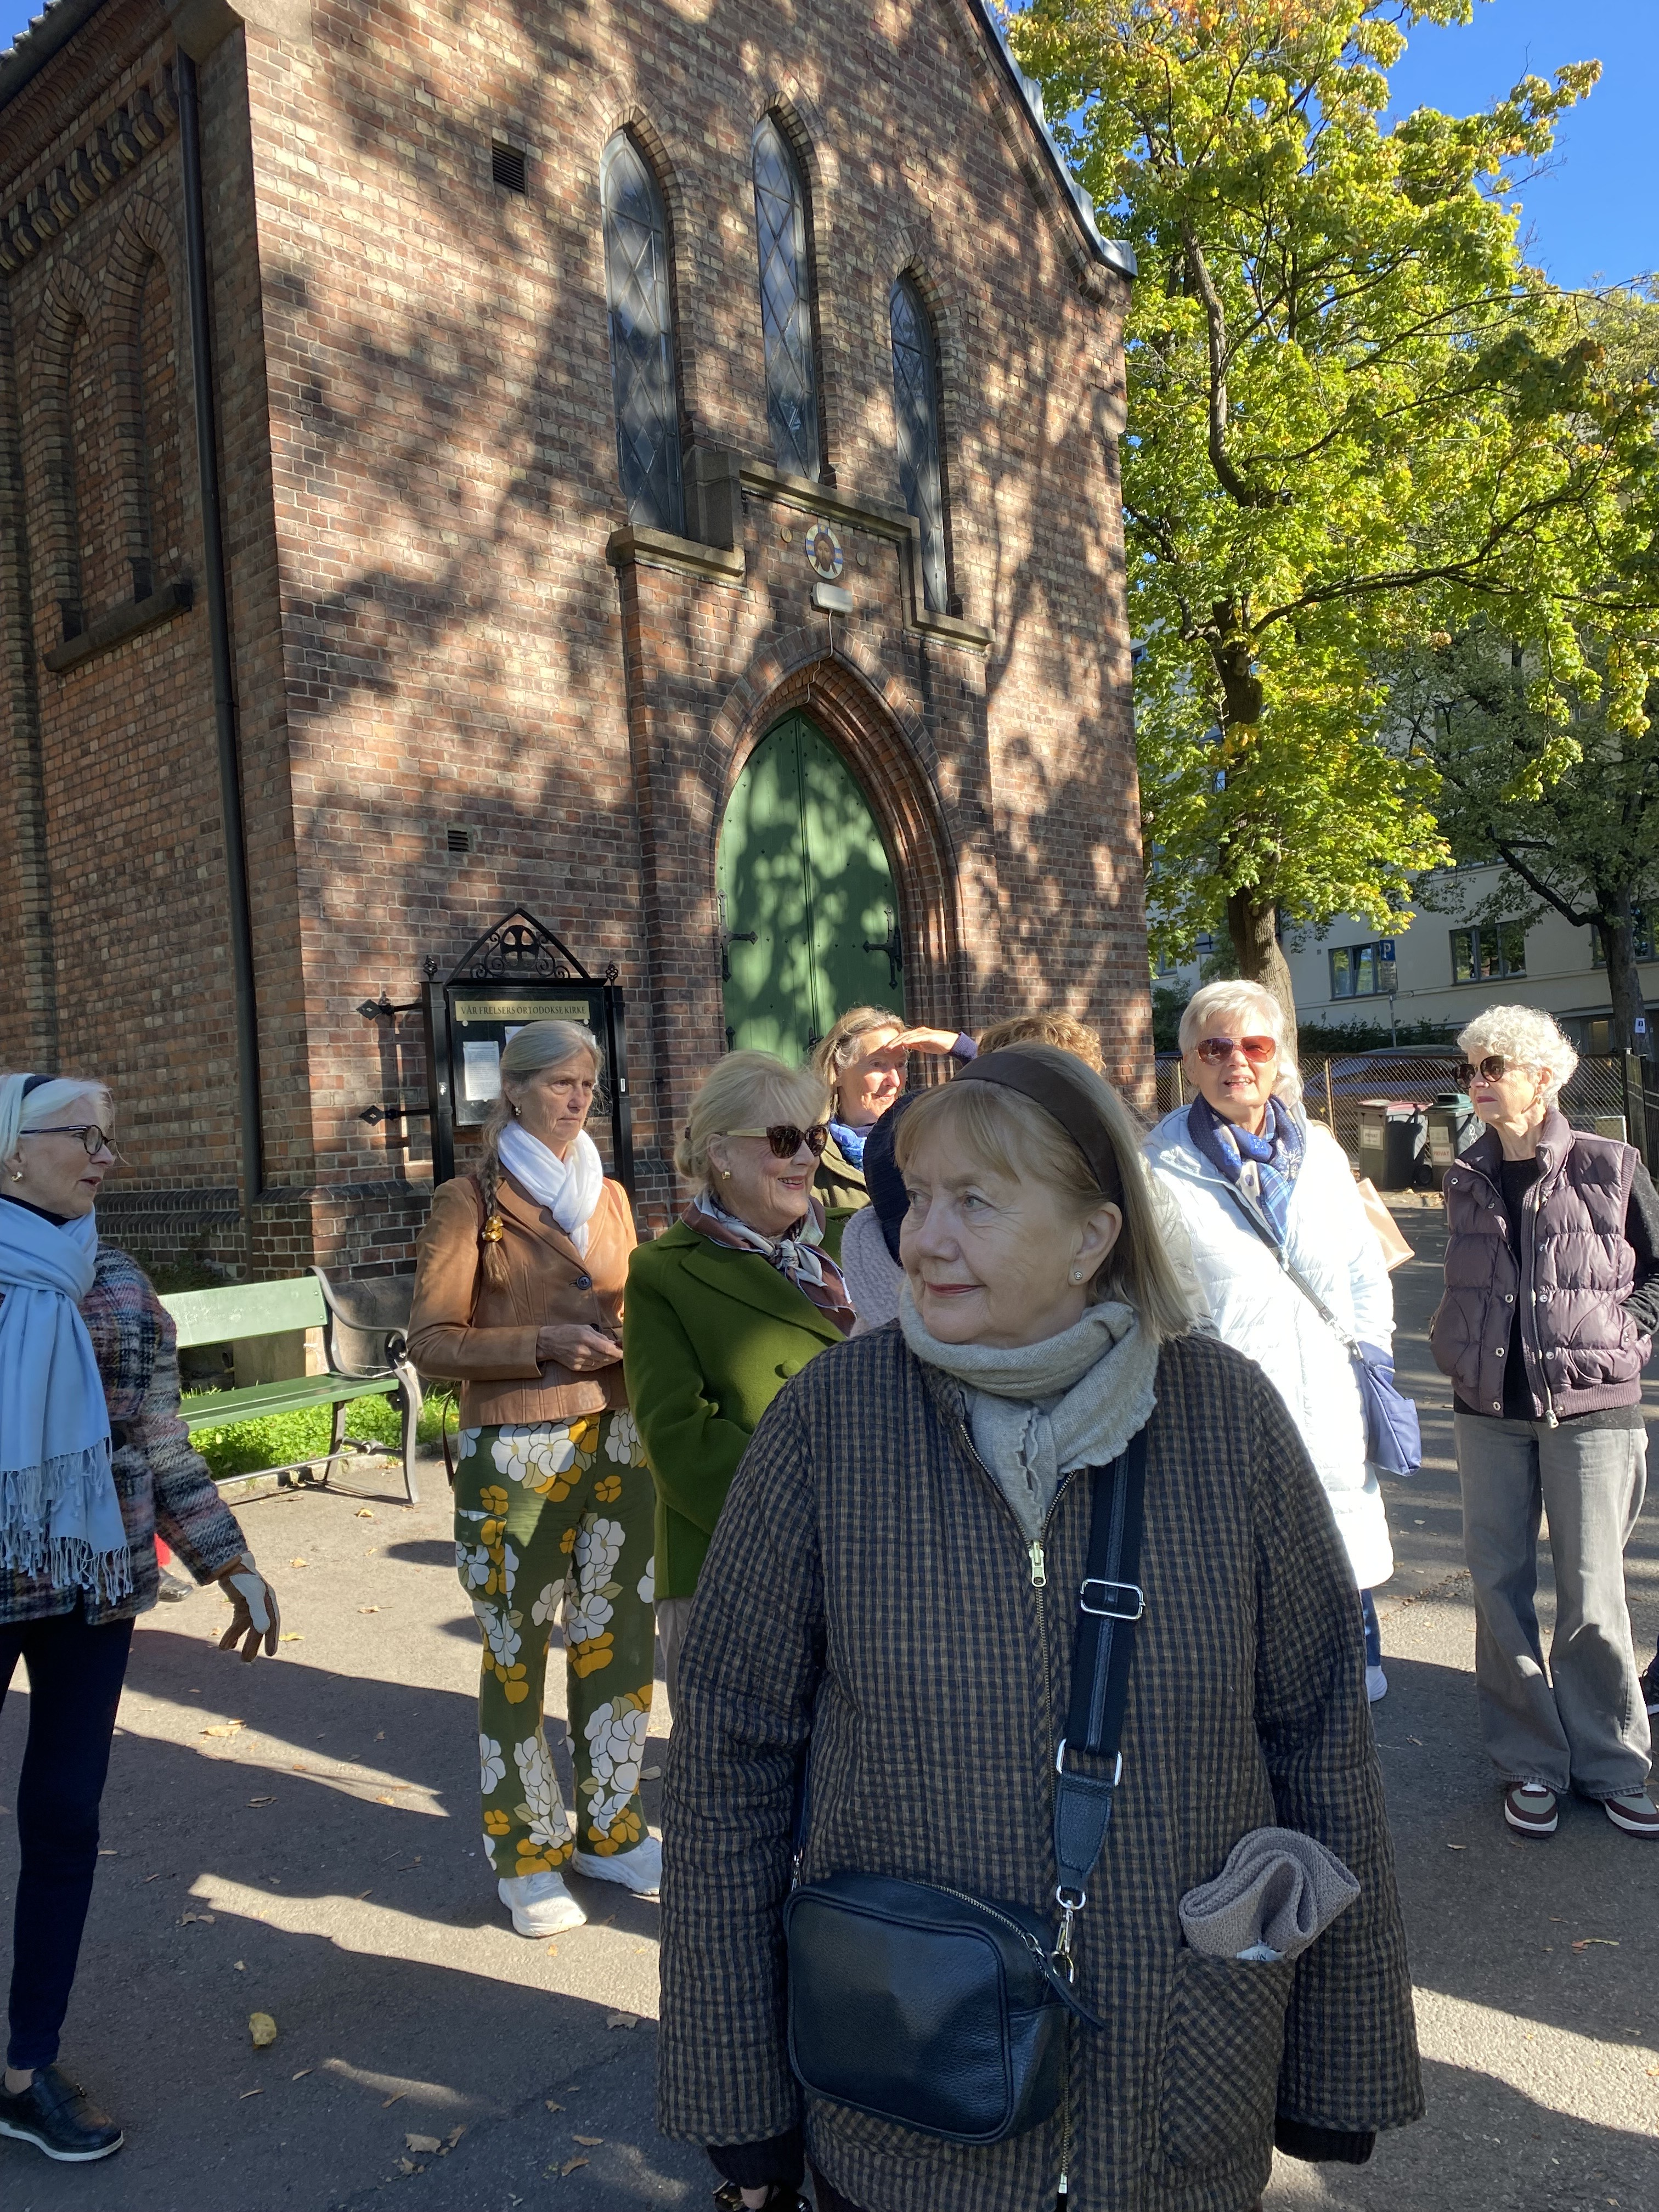
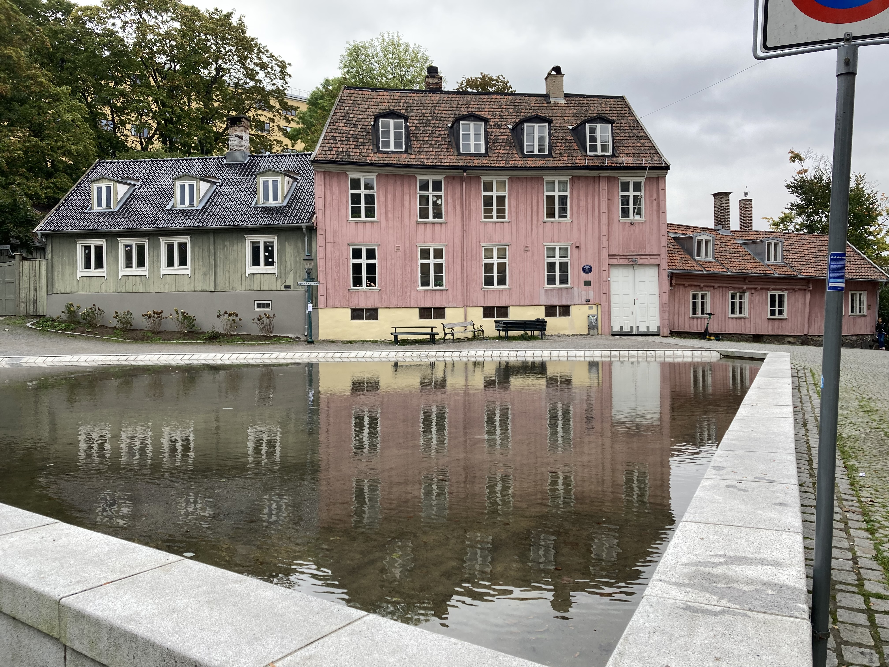
On our right, just inside the east entrance to Vår Frelsers (Our Saviour’s) cemetery, stands the Saint Olga Russian Orthodox Church, named after Princess Olga from Kyiv (ca. 900 AD). This church has over 5000 members, including many Ukranian refugees. The graves of many famous people can be found here. We saw the grave and beautiful headstone of Henrik Wergeland, a renowned 19th-century Norwegian poet.
Damplassen and Wergeland’s House
Outside the Saint Olga Church

We continued on to Damplassen where Henrik Wergeland and his wife lived. The area round Damplassen and its lovely pond – Damstredet and Fredensborgveien with colourful old wooden houses – is very idyllic. Wergeland kept his horse Veslebrunen in a stable behind the house. He mounted Veslebrunen every day and rode down to Akershus fortress, where he worked as Keeper of the National Records. Henrik Wergeland was known for his campaign to allow Jews to live in Norway. The law was changed, and Jews were allowed in 1851, six years after his death.
Weaver and textile designer Sigrun Berg lived at Damplassen and had her weaving shop here. She was especially famous for the purple scarf that Oslo’s radicals wore in the 1970s.
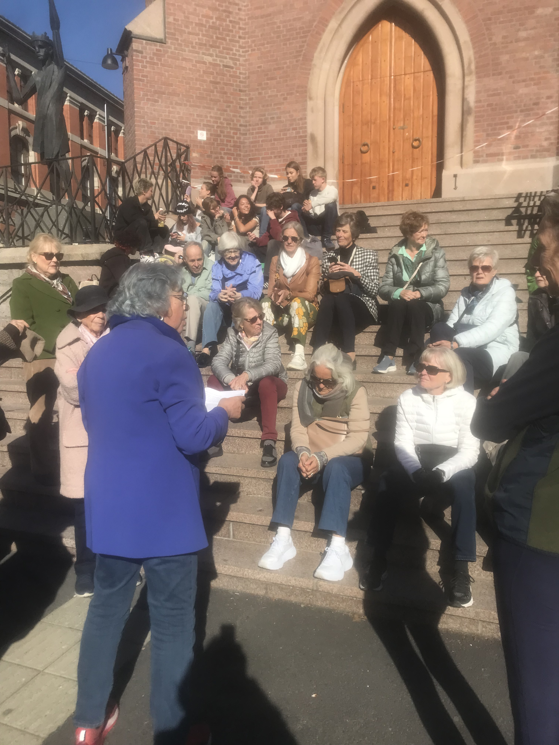
We then walked down to St. Olav’s Cathedral, the cathedral of the Roman Catholic Diocese in Oslo. This church, from 1856, is built in granite in neo-Gothic style and is situated on Halleluja Hill at the top of the Hammersborg area. The street near the church is called ‘Little Vatican’. After a rest on the church steps, we continued down, passing St. Sunniva School, founded by the catholic St. Joseph Sisters in 1865. This is a very popular school, with students from many countries, and its students have very good results.
On the Steps of St. Olaf Cathedral
There are many nice churches in the Hammersborg area: the Adventist Church, the Swedish Margaretakirkan, the St. Edmund’s Anglican church, and the magnificent Holy Trinity Church to name a few. We could also admire the classic style columns of the old Deichman library. This old library will become a photo museum, opening in 2027.
Many dramatic events have taken place in Akersgaten. In 1976, there was a huge conflict regarding Akersgaten 73, an old building which housed Oslo Forsøksgymnas – a progressive experimental high school built on the idea of democracy for all. The Salvation Army needed new headquarters, and the City Council decided to demolish the school building. This caused massive resistance and commotion from both the school, its students and the citizens of Oslo. An ‘army’ of police, horse guards, and dogs were brought in, and many were arrested. The building was demolished; and in 1979, the Salvation Army could rebuild and move into new headquarters.
We moved on to the Government quarter where the terrorist attack of July 22, 2011, started. Scores of people died or were injured. This area has a lot of history. In the 1800s, it was called the ‘Empire Quarter’, and the Military Hospital and Rikshospitalet – which have since been moved – were located there. In 1906, the first government building, designed by Henrik Bull, was erected, and in 1958 ‘Høyblokka’ (main government building) was completed. Much was destroyed in July 2011 and is now being rebuilt. Soon the public will be allowed into the Memorial Square in front of the entrance to the July 22nd Center of the new government buildings.
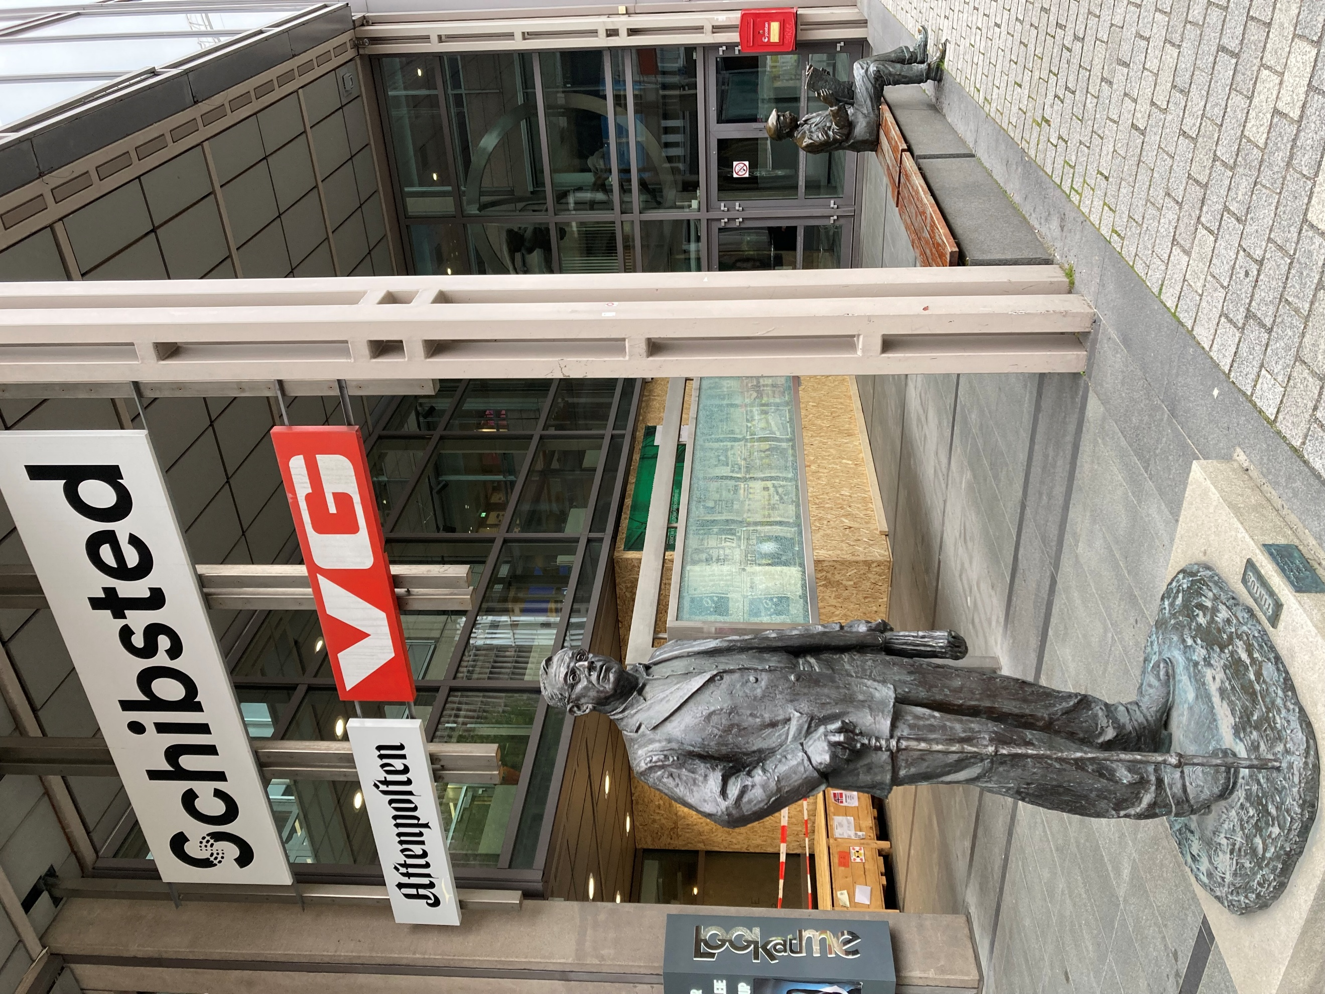
Our guide told us about sabotage actions carried out by the Second World War Resistance Movement. In 1944, the so-called ‘Oslo Gang’ blew up Nazi offices in both Akersgaten and Grensen. We then passed and admired the magnificent Italian Renaissance style building that houses the Norwegian Supreme Court.
Our tour finished at the VG building in Akersgaten 55 (the ‘Newspaper’ Street), the headquarters of Schibsted who own many newspapers, including Aftenposten and VG.
We admired the iconic sculpture of the VG man sitting outside on a bench reading his newspaper. Akersgaten continues past Stortinget as far as Akershus fortress. Before the fortress was built, Akersgaten ran to the fjord. We thanked Liv Berit Tessem for a most interesting tour and a dip into colourful history of this street and the surrounding area and neighbouring streets.
Many thanks to the Special Events Committee for arranging this tour.
Rosemary Hauge

ART COMMITTEE REPORT
LUDVIG KARSTEN: RESTLESS
Munch Museum
Tuesday, October 21
This is an exhibition that must be seen! It is a feel-good experience, much needed as we approach the dark autumn. Our favourite guide, Tonje Lieberg, brought to life an artist of whom we know far too little.
Ludvig Karsten (1876-1926) was only 50 years old when he fell down the stairs in his home in Paris and died. One can only wish that he had lived longer and taken his rightful place in art history.
Karsten was criticised 10 years after his death for not making a distinct contribution to art history. Art historians Håkon Stenstadvold, Reidar Revold, and Marit Werenskiold labelled him a ‘Late Impressionist’ in comparison to the later generation of Expressionists. The Late Impressionists were described as sensual colorists, egocentric, and quite often drunk. The Expressionists were seen as the true modern artists who innovatively used strong colours to express emotions.
Casting an eye around this exhibition, it is easy to see that Karsten is, in truth, more of a Fauvist or Expressionist! It is interesting to note that he is now exhibited in the Expressionist room in the National Museum. He should perhaps have taken his place in art history as an important bridge towards Expressionism.
Karsten travelled extensively from a young age. In Spain, he studied the art of El Greco and Diego Velásquez. In Paris, he saw exhibitions of Cézanne, Gauguin, and Van Gogh, and he moved in the social circle of the artists based in Montmartre. He met Picasso in 1909. He spent time with Matisse. He painted together with Edvard Munch in Åsgardstrand and visited the Skagen painters in Denmark.
In other words, he had an intense dialogue with the art history of his time. He borrowed motifs from all these artists and splashed them with his own strong colours. It is as if he says, ‘I can do what you all do, but I can do it differently.’ He experimented with the art movements of his day. We love the familiarity of the paintings and the hyped-up colours. We enjoy his interpretations with an open mind, but it is easy to see why he was condemned for never finding real originality.
The exhibition begins with still life and interior paintings. The first work has been carefully chosen as an introduction or synthesis of much that is to follow. Gobelin Tapestry 1911 has a modern still life in the foreground, and a paraphrase of an antique tapestry hanging on the wall behind. There is a disturbing crack across the picture where the canvas appears to have been cut. This sort of adding on and taking away, sewing or glueing appears in a handful of other paintings. There is no clear answer as to what Karsten was up to. He may have decided that this picture was better as two works. He cuts the feet off the bird which would have been easy to paint over. He may be right, but then he decides, ‘No, I like it better as a whole…’
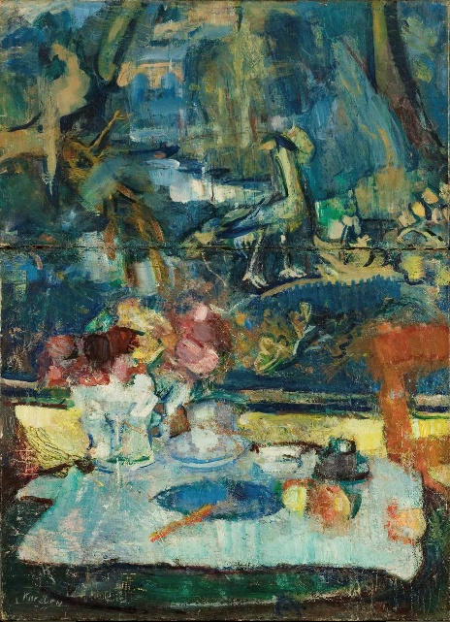
Gobelin Tapestry 1911
The still lifes remind us of Cézanne and Van Gogh but are perhaps more dynamic and vibrant. There is a restless nature to the compositions that we find different and interesting.

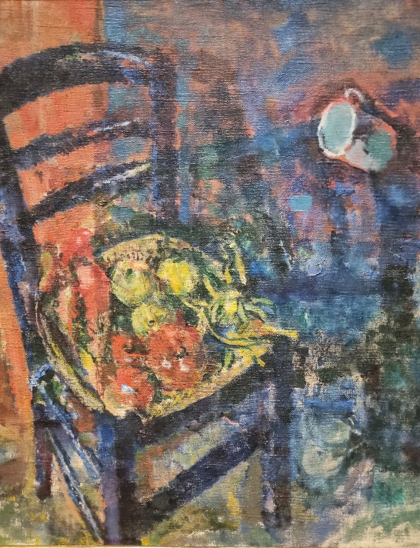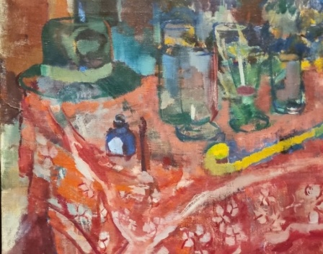
The Blue Chair 1923
Karsten's best interiors were made from around 1911. The Blue Kitchen 1913 brings the Dutch artist Vermeer to mind, whereas At the Window 1915 and The Red Room 1913 resonate with various Munch paintings.
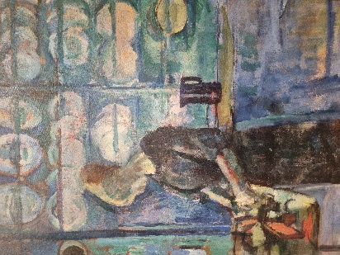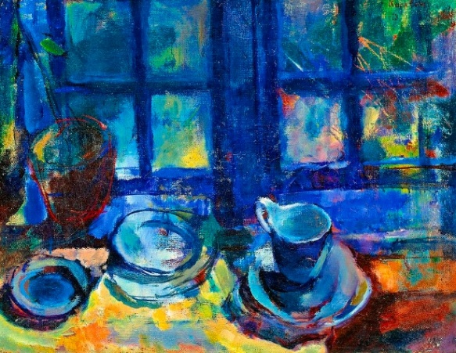
From My Blue Kitchen 1913 My Blue Kitchen 1913

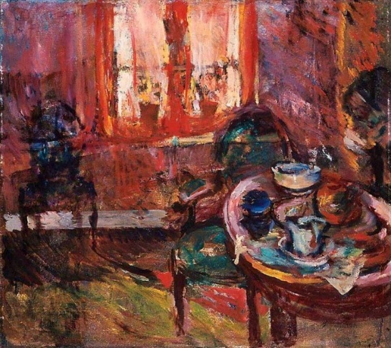
The Red Room 1913
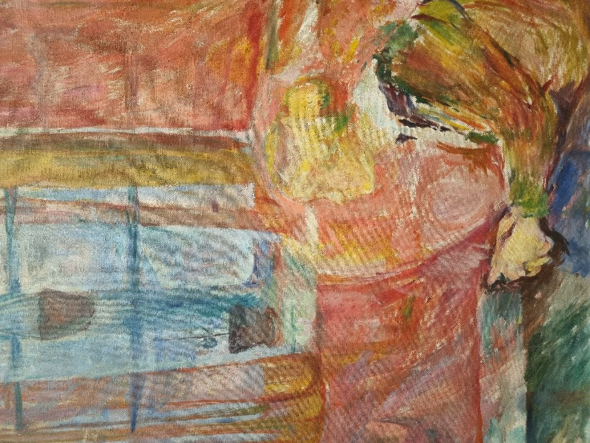
At the Window 1915
Karsten was very popular in his time and was heralded as the heir to Munch in Norway. The exhibition shows that the motifs he found, or borrowed, were starting points for his experiments with colour.
Much has been made of his paraphrases of Old Masters. Rembrandt’s Bathsheba gains greater vibrancy under Karsten’s brushstrokes. As do the other monumental canvases on show. Golgotha brought Chagall to mind.
His portraits vary in style from sombre to decorative. Red Hair 1907 could just as easily have been a van Gogh; the portrait of Consumption 1907 looks almost like a copy of Munch’s Sister Inger, and other portraits have the decorative lightness of Matisse.
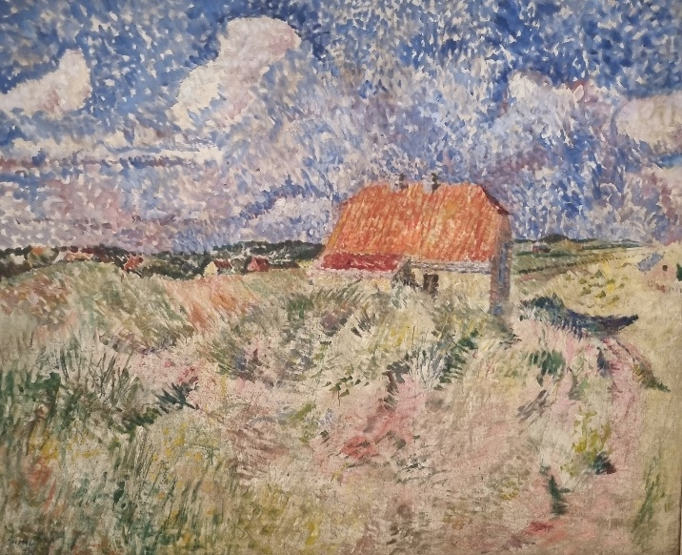
He also has a go at Pointillism and all aspects of Impressionism. Casting your eyes around each room in the exhibition feels as if you have seen it all before. And yet, you have not. There is a distinct style to Karsten.
As so often, I would like to include copies of just about all the paintings on show. Not only that, but it would be so satisfactory to juxtapose similar paintings by other artists and discuss the differences.
Suffice to say that Karsten did not push to exhibit his work himself, which is one reason why he “disappeared”, and we can be grateful that these artworks have been put together, bringing Ludvig Karsten back into the public art domain.
Go and enjoy all these wonderful works!
Our grateful thanks to Inger M. Ræder for arranging this event.
Jane Steenbuch

IN MEMORIAM
Kirsten Wensell
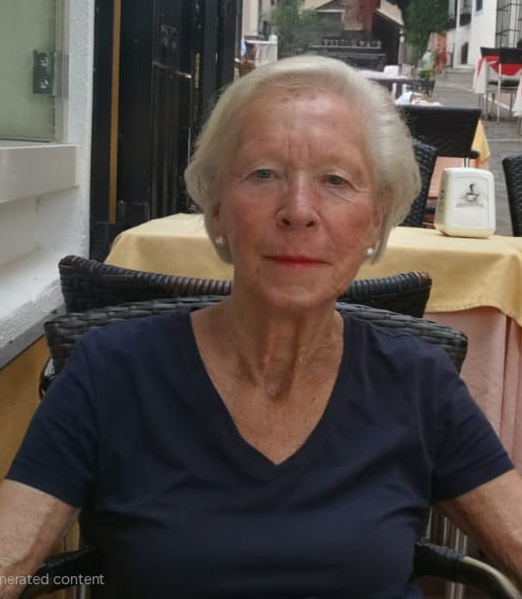
26.06.1944 - 28.09.2025
On Sunday, September 28, I received the sad message that long-standing Forum member Kirsten Wessel had passed away during the night. Although Kirsten had been ill for quite some time, her passing came as a shock.
Kirsten served the Forum in many capacities. She worked for years in the Office, at a time when we were open for business three days a week. She has also served as Deputy Board Member and helped with the Newsletter Dispatch Team.
Before she became ill, she participated in the Walking Group and was instrumental in getting me into that group. She was always a cheerful, friendly and very elegant woman!
Kirsten obtained a degree in biochemistry from Ullevål Hospital in 1967 and worked for long periods at the Institute of Experimental Medical Research at the University Hospital in Oslo. She became the Institute’s general manager, a position she returned to several times after diplomatic postings abroad.
As an FO member, she accompanied her husband Lars to several countries, both in Europe and in the Far East. Thailand definitely became her favourite, and after she and her husband retired, they still went back every year. Since their son and his family were living there, she always said that she had a good excuse to travel!
They are all back in Norway now.
My husband and I are longtime friends with Kirsten and Lars, and she will be greatly missed both by us, but also by her many Forum friends.
Berit Lindstrøm

A R O U N D O S L O
Fjord Oslo Festival of Light
November 7 – 12
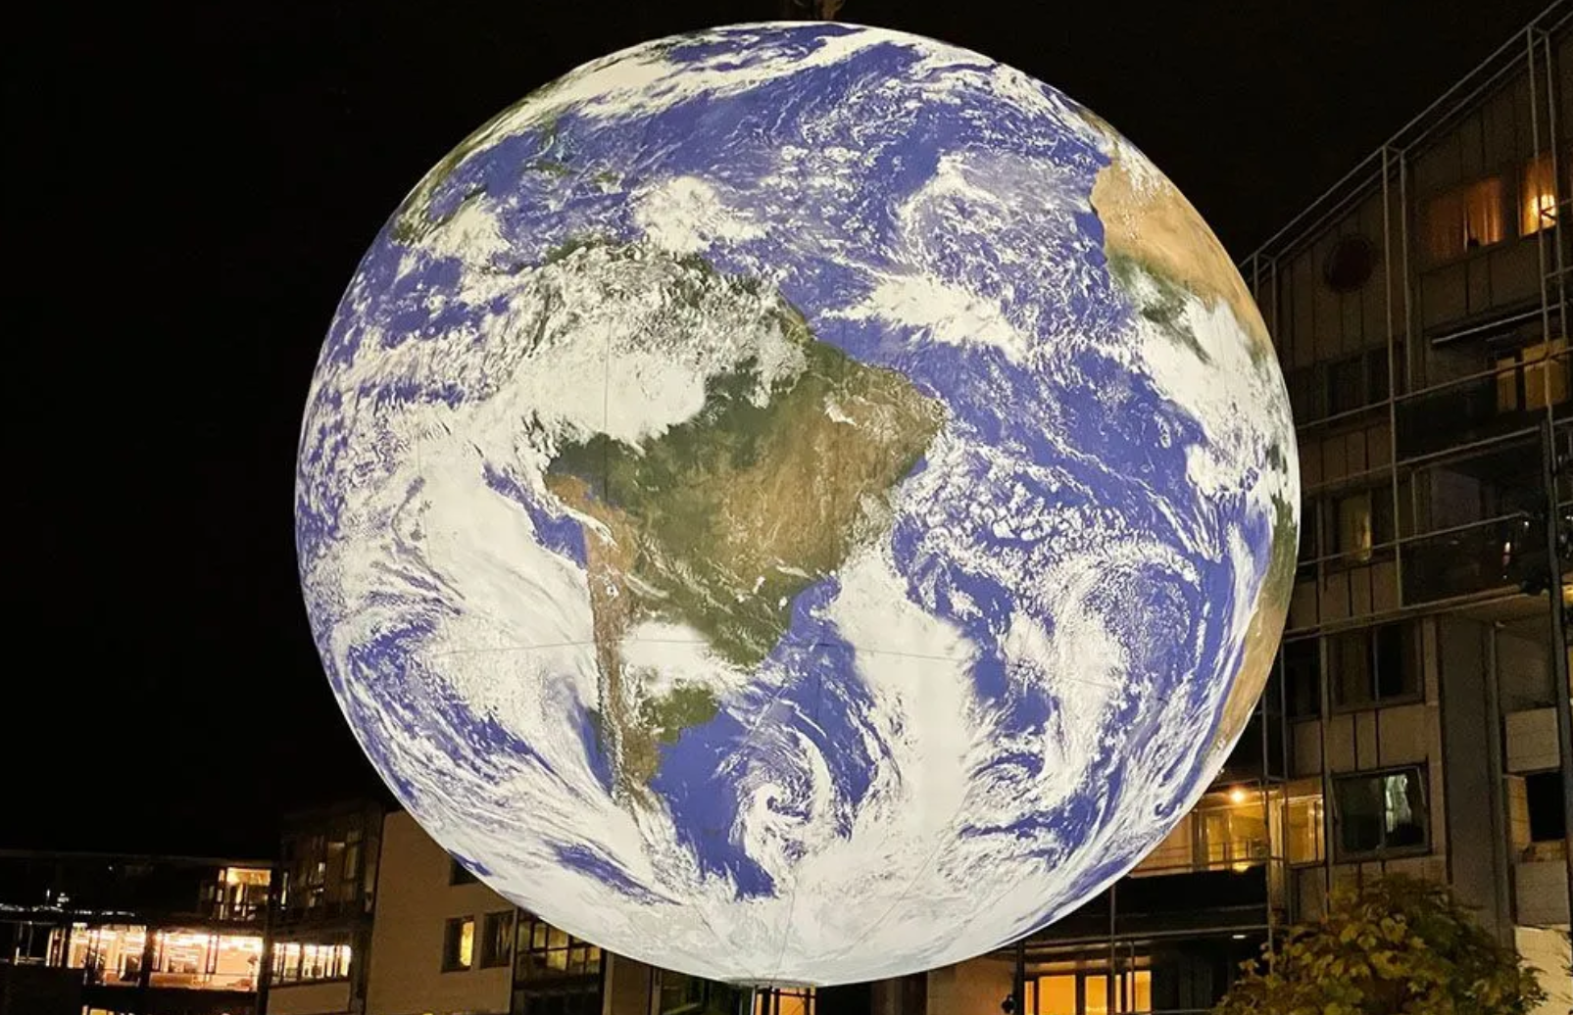

If you are visiting Oslo in November, one of the best things to do is to join the Fjord Oslo Light Festival. Every year in November, in the evening, Aker Brygge turns into a spectacular light scene for four days in a row! Fjord Oslo is an amazing light show presented by renowned artists, offering a powerful and inclusive experience to everybody.
These light shows are not merely a beautiful experience pleasant to the eyes (even though they are that, too); they touch on important and urgent subjects, thus inviting the audience for a broader discussion. Presenting various forms of light art – from intimate installations to projections onto landmark buildings, Fjord Oslo offers a truly fabulous experience for everybody visiting Oslo in November.
Visiting Oslo in November | Best Things To Do in Oslo, Norway
INTERNATIONAL FORUM

Org.no: 994 566 806

Interim Board
Coordinator: Åsny Wedege Walters

Editor: Elizabeth S. Rasmussen

Editorial Team: Elspeth Walseth, Robin Wittusen and Renate Scapin

The Editor and the Editorial Team reserve the right to edit all material.

Dispatch: November 3, 2025

